PROCEEDINGS OF THE YEREVAN STATE UNIVERSITY
УЧЕНЫЕ ЗАПИСКИ ЕРЕВАНСКОГО ГОСУДАРСТВЕННОГО УНИВЕРСИТЕТА
Geology and Geography 58(2), 2024 Геология и география

Geography

УДК 625.72:528.4

COMPREHENSIVE ASSESSMENT ROADSIDE INJURIES THROUGH HIGH-RESOLUTION THREE-DIMENSIONAL LASER SCANNING
E. M. HOVSEPYAN ∗

Chair of Cartography and Geomorphology, YSU, Armenia

Roadside injuries are a significant concern within transportation infrastructure, necessitating effective monitoring and assessment methodologies. In this study, we introduce a novel approach for evaluating roadside injuries using high-resolution three-dimensional laser scanning systems. Through a meticulous selection process based on road cover characteristics, we implement a localized roadside monitoring methodology. The aim is to accurately identify and assess injuries, leveraging the precise data captured by laser scanning systems. By analyzing this data, we seek to provide practical insights for informing future road surface restoration activities. This research contributes to enhancing the efficiency and precision of roadside injury evaluation, ultimately facilitating improved maintenance and safety measures within transportation networks.
https://doi.org/10.46991/PYSU:C.2024.58.2.095
Keywords: GNSS, IMU, LiDAR, TIN, RINEX, CHCNAV.

Introduction. Highways and roads constitute critical elements of transportation infrastructure, significantly influencing traffic organization and economic connectivity. Since the 1950s, extensive efforts have been dedicated to the maintenance, regulation, and management of transport infrastructure, in line with the pace of economic development and the growing demand for effective communication channels [1]. The assessment of road conditions involves evaluating changes in surface layers caused by external forces, adherence to operational standards, and three-dimensional dimensions of infrastructure. This assessment offers insights into monitoring the physical alterations roads undergo. However, the evaluation of changes in rough road infrastructure nationwide often relies on visual inspection [2]. Leveraging modern precision geodesic equipment, especially laser scanning systems, provide multispectral opportunities for planning coordinated assessment and management strategies for road infrastructure [3, 4].
LiDAR (Light Detection and Ranging) are currently recognized as the sole equipment capable of conducting three-dimensional (3D) scanning and collecting 3D global position data for the scanned surface (X, Y, Z). LiDAR systems have integrate GNSS (Global Navigation Satellite System) for global positioning and IMU (Inertial Measurement Unit) for measuring rates of intertia [5]. The synchronized operation of these systems guarantees uninterrupted data collection, evenin the absence of satellite communication. This study details the procedures for identifying and assessing road surface injuries, utilizing 3D scanning data conducted by “Center of Geospatial Technologies” LLC. The scanning process employed the AU20 (AlphaUni20) LiDAR system issued by CHC Navigation. The scans were conducted in the vicinity of the intersections between Tbilisi Highway and Paruyr Sevak Street, as well as the intersection of Tbilisi Highway and Zakaria Kanakertsi Street, in Yerevan, Republic of Armenia. Notably, this area underwent a 2.7 km water pipe renovation during September, 2023. Subsequently, the area was asphalted; however, due to incomplete technical standards, a depression of 1.5 cm–7.0 cm persists relative to the road level. Data retrieval and processing were conducted within the ArmRef02 coordinate system.
Purpose and Methods of Research.
The Objectives of this Study are as Follows:
1. Development of a methodology to distinguish the object of interest from the recorded data:
- automated segmentation of the road surface from the 3D scanning point cloud.
2. Identification of potential approaches for highlighting the research subject within the study area:
- automated detection of road surface injuries.
3. Ensuring practical application of problem-solving to the research subject:
- calculation of the volume fractures resulting from water pipe repair at the longitudinal intersection of the road, relative to the road plane. This calculation can serve as a basis for estimating the volume of compacted soil fill required for repairing the specified road section.
During road surface evaluation, automated analytical algorithms provided by the LIDAR360 MLS software environment were employed [6]. These algorithms
are based on a methodology for comparing surface dimensions, effectively
distinguishing surface lesions. The calculation of fracture volume resulting from the water pipe repair was conducted in the ArcMap software application environment using an analytical method of calculates the volume of the spatial body resulting from surface intersection and the limiting plane.
Road Surface Seperation. The acquisition of basic points for assessing roadside injuries in the area under review was conducted in two phases: tower sourcing and post-processing of documented data. During the field recording process, the scanning was conducted using a combination of two systems, the AU20 LiDAR system and the GS18 GNSS rover. The GS18 GNSS rover functioned as a base station for collecting of static satellite data, stored in RINEX format. The GNSS receiver of the AU20 LiDAR system could establish a connection with the GS18 GNSS rover within a radius of 10 km, operating in the base mode. Data collected by the rover in base mode served as the basis for the post-processing the data generated by the scanning system. When a satellite connection was established, the AU20 LiDAR system initiated its inertial system. The startup of the inertial system was followed by the commencement of the scanning process. During the post-processing stage of the acquired data, the satellite static data gathered by the GS18 GNSS rover is combined with the scanning results from the AU20 LiDAR system. The post-processing follows the scanning route (Fig. 1).

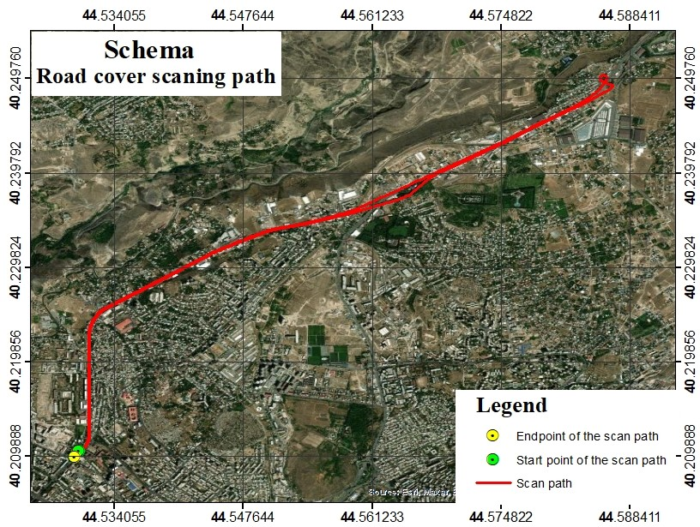

Fig. 1. Scanning route for the area under review.

Algorithmic calculations utilizing GNSS and IMU systems are employed along the scanning route to generate a georeferenced 3D point cloud. Subsequently, a balancing and filtration phase is implemented to enhance locating accuracy and remove “noise” and deflected points (isolated points) from the point cloud.
The outcome is an interconnected point cloud with a possible 3D deviation of up to
5 mm, although this deviation is in a global position. The maximum intra-scan deviation is 2 mm, contingent upon the optical capabilities of the scanning mechanism (Fig. 2).
As part of scanning the road infrastructure cover, besides the road surface,
the roadway section was also scanned, although it is not addressed in this study.
The road surface analysis toolkit of LIDAR360 MLS software was utilized to separate a busy segment of the road (Fig. 3).
It’s important to highlight that the effectiveness of surface separation in areas is influenced by the presence of machinery during scanning. The surface separation process automatically removes 3D points touched by machinery, resulting in locally unscanned areas. These passages were reconstructed using the TIN (Triangulated Irregular Network) method (Fig. 4).

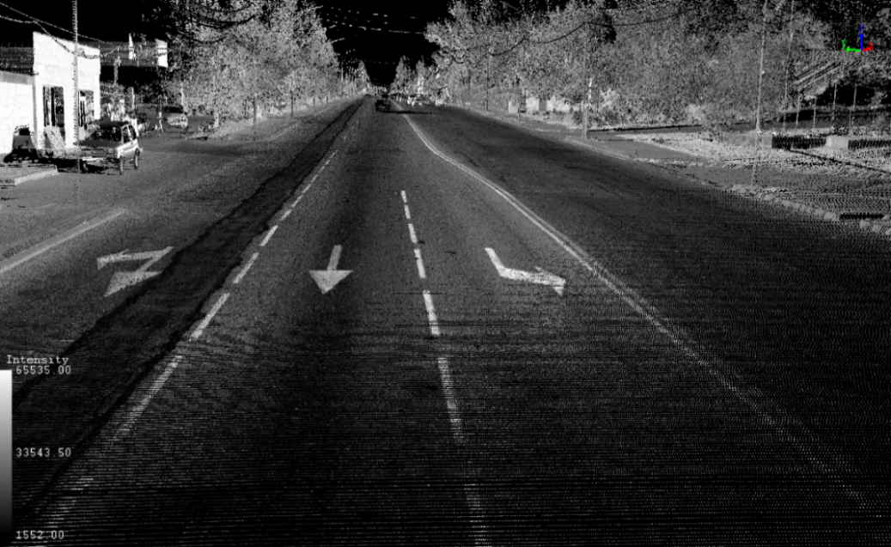

Fig. 2․ Point cloud generated from scanning, incorporating intensity values.

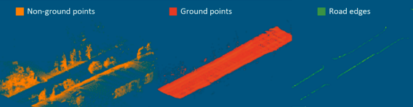

Fig. 3. Separating the road surface from the point cloud.

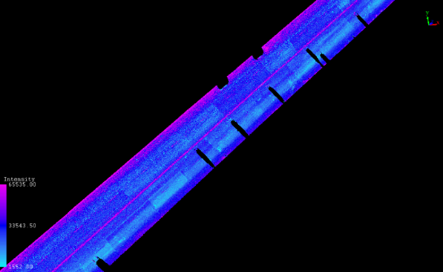 | 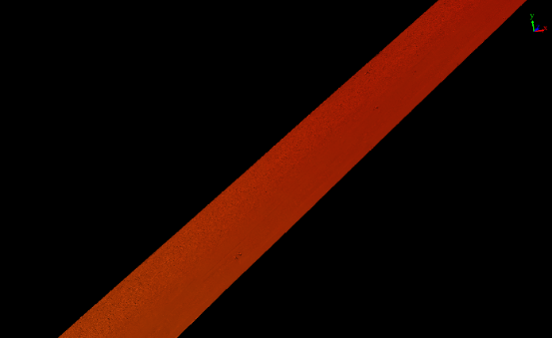
Fig. 4․ TIN model generated from point cloud.

Detection of Roadside Injuries. Identification of specific roadway injuries was conducted utilizing the “Detect Damage” tool within the Road surface analysis toolkit of LIDAR360 MLS software. This tool generates a vector file in shp/dxf/kml format delineating the boundaries of the lesions on the road surface. The focus of this study was primarily on fracture resulting from the repair of the water pipe within the study area (Fig. 5).

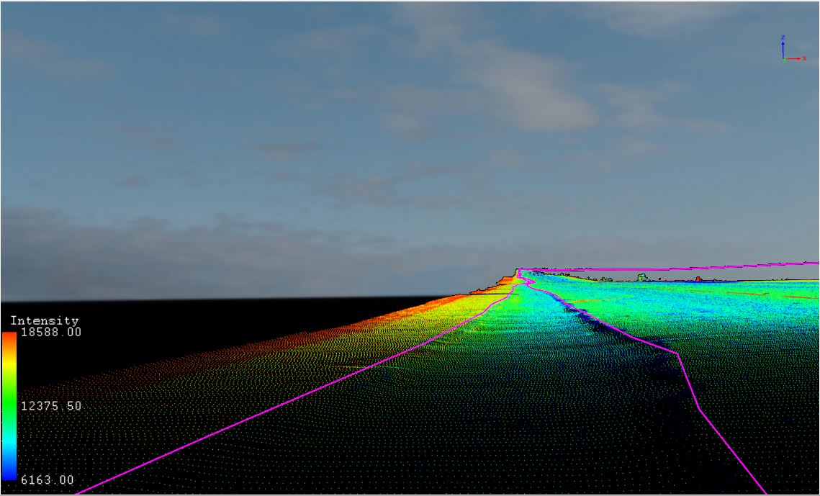

Fig. 5․ Automated roadside injury outline.

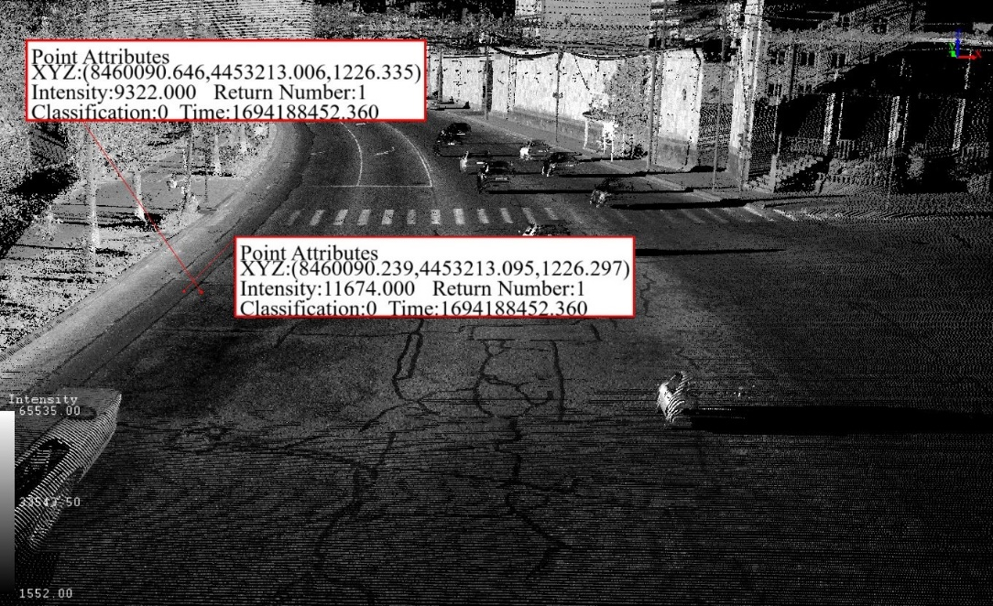

Fig. 6. The difference between road surface damage and cover height.

From a structural perspective, similar injuries on road surfaces can lead to traffic congestion and may also pose technical challenges for vehicles traversing the affected road sections. International experience suggests that deficient transportation infrastructure not only deteriorates traffic conditions and the operational state of vehicles, but also exerts economic impacts on other interconnected infrastructures [7]. Significant disparities in elevation on road surfaces could also contribute to traffic accidents. As a result, of the incomplete implementation of technical norms by the construction company, the first line of the congested section of the road, which by the way is considered a zone for public transport, was affected. During the study, both cross-sectional and longitudinal slopes of the road surface were considered, accounting for the technical specifications of the road․ Technical standards also factored in the standard inclination of 1 m per 2‰ from the center to the edges of the road crosswise [8]. The disparity in surface height is conspicuous within a confined area (Fig. 6).
Transferring the automated digitized surface layer of road injuries to the ArcMap software application facilitates practical analysis.
Roadside Injury Assessment. A method has been developed to accurately calculate the volume of roadside injuries, facilitating precise determination of the amount of “missing” hard ground. Considering the road’s transverse and a longitudinal slope, the plane formed by the “filling” ground varies depending on
the road profile slope and its position realitve to the center of the transverse section. The essence of the method involves constructing a vector layer at 1 m intervals along the entire length of the injury to compute the volume of depressions on the surface of the road covering. These points, providing 3D global position data from the road surface, serve as the basis for creating fragmented surfaces, with points at the ends of these surfaces defining their boundaries. These surfaces, generated along the injury, determine the extent to which rigid ground filling is required for each road section to meet technical specifications.
Upon filling in these dimensions, the longitudinal view of the road surface complies with technical specifications. The resulting surfaces intersect with the road surface, raising the injury floor proportionately to its depth. In the ArcMap software environment, the polygon volume tool calculates the volume of roadside injuries beneath all surfaces. In order to calculate the volume of the sections, it was necessary to determine the height of the filling plane. The height determination is based on geometric analytical methods, the determination of the height of the polygonal center in a 3D plane, if the height values of the polygonal ends are known. The height determination of the center of the armpit was carried out using the following
formula:
$$Z_{r}=\frac{Z_{a}+Z_{c}+Z_{e}+⋯+Z_{n}}{n},$$
where Z_{r} is the center height, Z_{a}, Z_{c}, Z_{e}, ... , Z_{n} represent the height of the summits, and n is the number of summits. The above formula determined the altitudes of the centers of polygons filling the entire road surface. Below is the layout of the section for assessing the volume of cover injuries (Fig. 7).
The estimated volume of road surface injury of the studied area, representing the total volume of required compacted hard ground, is 88.63 m³.
Access the database utilized and generated during the study via the following link [9].

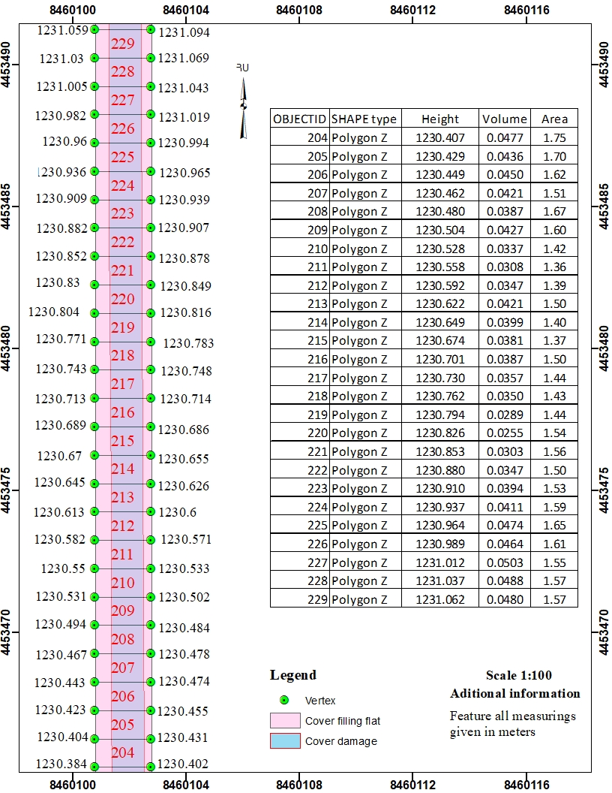
N

Fig. 7. Plan for Roadside Injury Assessment.

Conclusion. Within the framework of this study, Tbilisi Highway. A result of the study, it was possible to identify injuries on the road surface of the object under review, the Tbilisi Highway. Identifying types of injuries resulted in types of injuries such as pits, fractures, cracks, and more. The study emphasized the fracture of the cover resulting from the repair of the water pipe. The damage, which is large enough to be 2.7 km in length, is a factor damaging the power and stability of the road from the engineering aspect, the consequences of which are varied both in terms of the impact on the traffic and in terms of the safety concept. The practical application of the study was to localize the use of high-resolution laser scanning systems in communication direction monitoring processes. As a result of the survey, it was possible to perform calculations and determine the amount of hard ground required to recover the cover. Laser scanning systems, which today are actively used by developed countries for road monitoring, can be a great incentive for monitoring of communication channels in the territory of the Republic, which in turn will contribute to the optimal distribution of time and resources used. The benefits of using laser systems can also be pointed out by reducing the human factor in the data collection process in field conditions, which reduces the likelihood of accidental
and gross errors. Based on the results of this study, I propose to expand the monitoring methodology of communication channels to include LiDAR systems from modern geodetic equipment, the advantages of which are obvious. Multiple points can be noted from the benefits of localization and application, but
from an access point of view, such systems have great values today, from which it can be assumed that the preference for the application and operation of such systems must be met by the relevant governmental structure. The efficiency of using these systems, however, is a one-time major investment and a two-way operation at no additional cost.
Received 10.05.2024
Reviewed 11.06.2024
Accepted 15.07.2024
REFERENCES

- Kiziltas S., Akinci B., et al. Technological Assessment and Process Effects of Field Data Capture Technologies for Construction and Facility/Infrastructure Management. Journal of Information Technology in Construction 13 (2008), 134–154.
http://www.itcon.org/2008/10
- The Interstate Standard of Public Roads. Rules for the Design of Highways. GOST 33100-2014.
- Kukko A., Kaartinen H., et al. Multiplatform Mobile Laser Scanning. Usability and Performance. Sensors 12 (2012), 11712–11733.
https://doi.org/10.3390/s120911712
- Park H.S., Lee H.M., et al. A New Approach for Health Monitoring of Structures: Terrestrial Laser Scanning. Computer-Aided Civil and Infrastructure Engineering 22 (2007), 19–30.
https://doi.org/10.1111/j.1467-8667.2006.00466.x
- Riveriro B., Gonzalez-Jorge H., et al. Laser Scanning Technology: Fundamentals, Principles, and Applications in Infrastructure: In: Non-Destructive Techniques for the Reverse Engineering of Structures and Infrastructure. UK, London, CRC Press (2016), 7–33.
- Yadav M., Lohani B., Singh A.K. Road Surface Detection from Mobile Lidar Data. ISPRS (2018).
https://doi.org/10.5194/isprs-annals-IV-5-95-2018
- Guo J., Tsai M.-J., Han J.-Y. Automatic Reconstruction of Road Surface Features Using Ground Mobile Ledger. Automation in Construction 58 (2015), 165–175.
https://doi.org/10.1016/j.autcon.2015.07.017
- The Interstate Standard of Public Roads. Geometric Elements. GOST 33475-2015․
- https://drive.google.com/drive/folders/1EB6DlYMuYOKTNrNabZBACf3-Nb6X0Zol?usp=drive_link
Է․ Մ․ ՀՈՎՍԵՓՅԱՆ

ՃԱՆԱՊԱՐՀԱՅԻՆ ԾԱԾԿԻ ՎՆԱՍՎԱԾՔՆԵՐԻ
ՀԱՄԱԼԻՐ ԳՆԱՀԱՏՈՒՄԸ ԲԱՐՁՐ ԼՈՒԾԱՉԱՓԻ ԼԱԶԵՐԱՅԻՆ ԵՌԱՉԱՓ ՍԿԱՆԱՎՈՐՄԱՆ ՀԱՄԱԿԱՐԳԻ ՄԻՋՈՑՈՎ

Ամփոփում

Ճանապարհային վնասը տրանսպորտային ենթակառուցվածքների հիմնական խնդիրն է, որը պահանջում է արդյունավետ մոնիտորինգ և գնահատման մեթոդաբանություն: Աշխատանքում առաջադրվել է ճանապարհային վնասների գնահատման նոր մոտեցում՝ եռաչափ լազերային սկանավորման համակարգերի ինտեգրմամբ: Աշխատանքի նպատակն է ճշգրիտ բացահայտել և գնահատել վնասը՝ օգտագործելով լազերային սկանավորման համակարգերից ստացված ճշգրիտ տվյալները: Վերլուծելով այս տվյալները՝ մենք նպատակ ունենք ապահովելու գործնական տեղեկատվություն՝ ապագա ճանապարհների վերականգնման ջանքերի համար: Այս հետազոտությունը նպաստում է ճանապարհային վնասների գնահատման արդյունավետության և ճշգրտության բարելավմանը, ինչը, ի վերջո, նպաստում է տրանսպորտային ցանցերի պահպանման և անվտանգության միջոցառումների բարելավմանը:

Э. М. ОВСЕПЯН

КОМПЛЕКСНАЯ ОЦЕНКА ПОВРЕЖДЕНИЙ НА ДОРОГАХ
С ПОМОЩЬЮ ТРЕХМЕРНОГО ЛАЗЕРНОГО СКАНИРОВАНИЯ ВЫСОКОГО РАЗРЕШЕНИЯ

Резюме

Повреждение дорог является серьезной проблемой в транспортной инфраструктуре, которая требует эффективных методологий мониторинга и оценки. В этом исследовании мы представляем новый подход к оценке дорожных повреждений с использованием систем трехмерного лазерного сканирования высокого разрешения. Благодаря тщательному процессу отбора, основанному на характеристиках дорожного покрытия, мы внедряем методологию локализованного придорожного мониторинга. Цель состоит в том, чтобы точно идентифицировать и оценить повреждения, используя точные данные, полученные с помощью систем лазерного сканирования. Анализируя эти данные, мы стремимся предоставить практическую информацию для обоснования будущих мероприятий по восстановлению дорожного покрытия. Это исследование способствует повышению эффективности и точности оценки дорожных повреждений, что в конечном итоге способствует улучшению технического обслуживания и мер безопасности в транспортных сетях.

∗ E-mail: erikhovsepyan104@gmail.com

